Task on IAM:  
==================

1. Create one IAM user and assign ec2,s3 full access role.

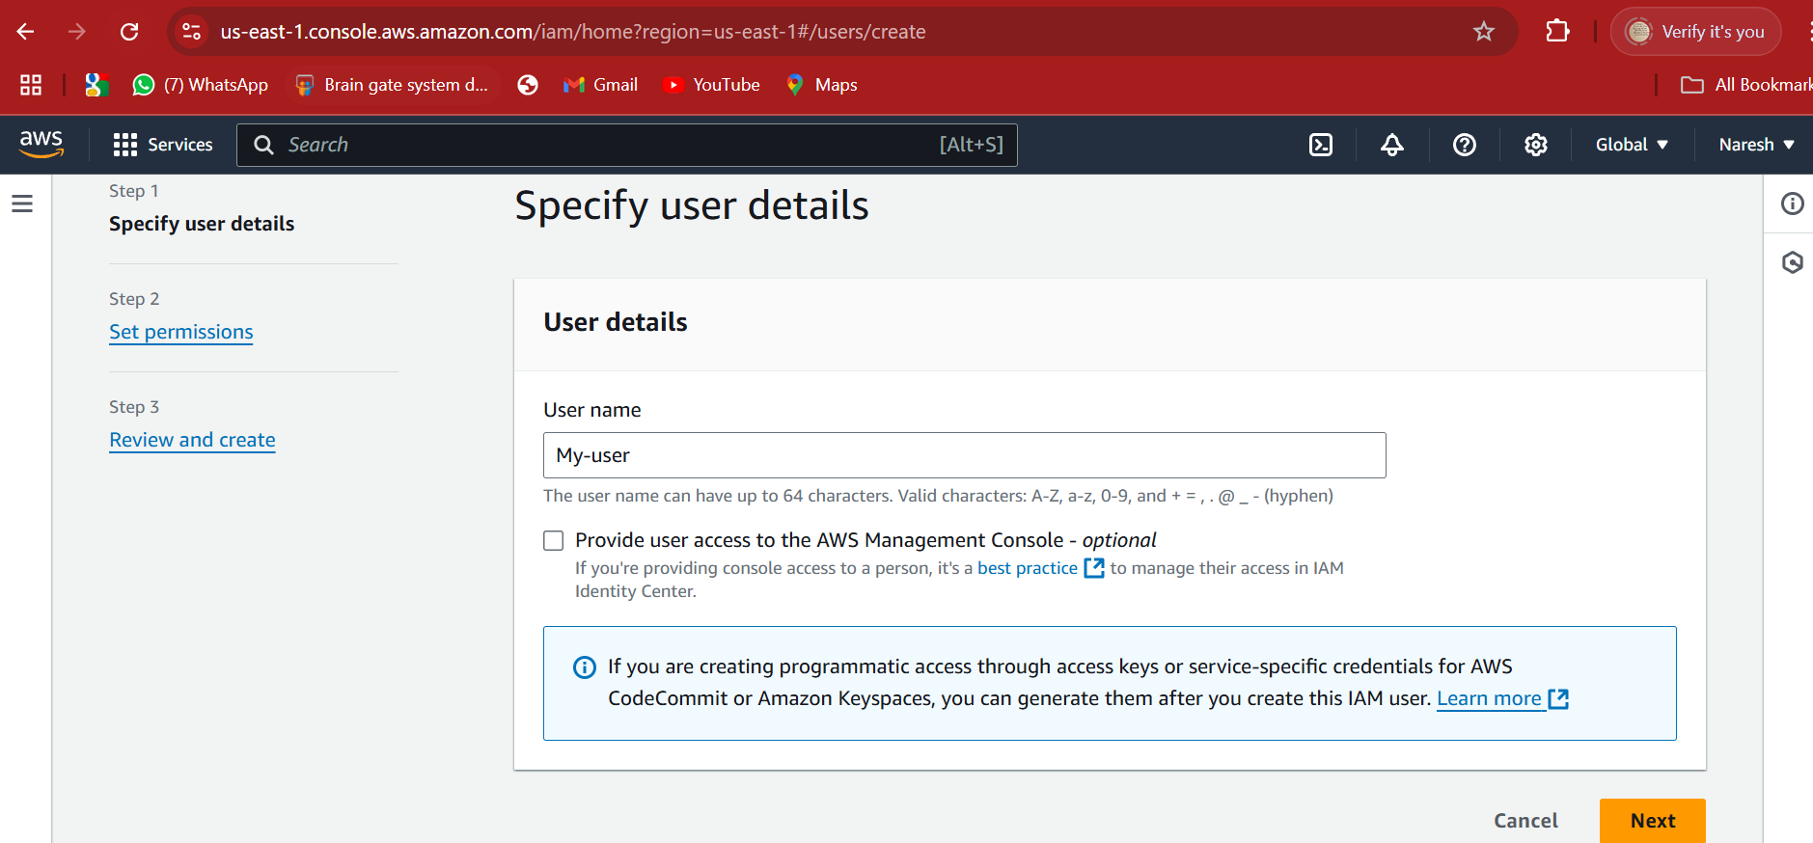

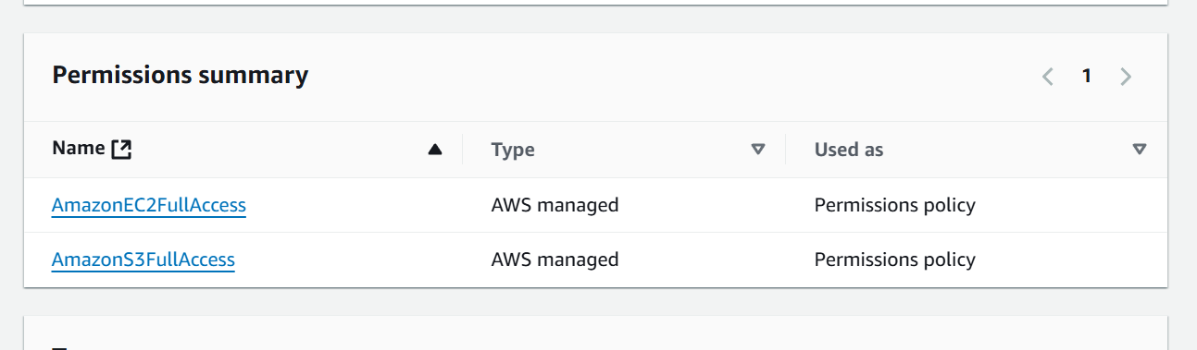

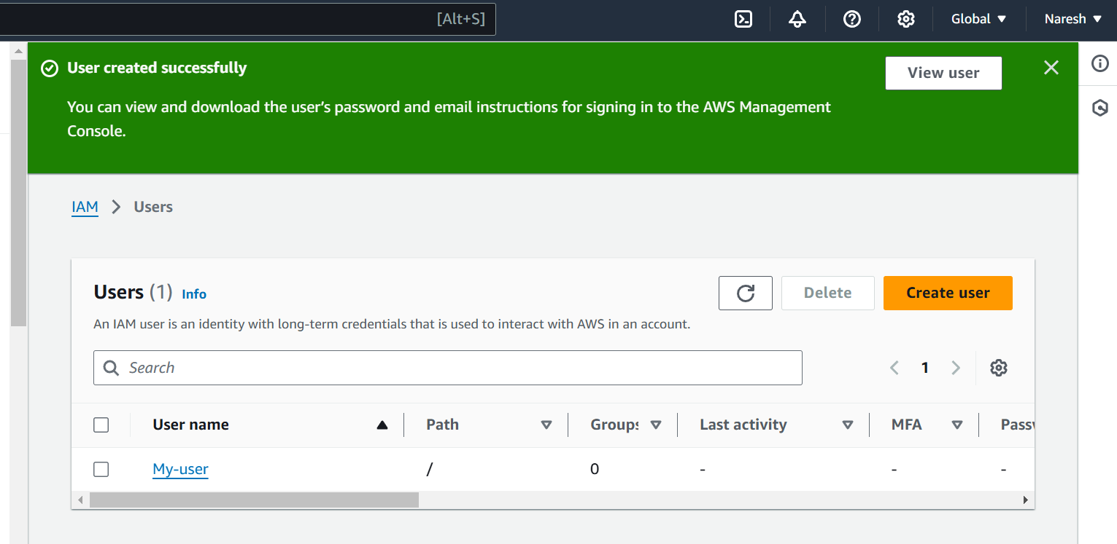

1. Create one Group in IAM and Assign Read access for ec2.

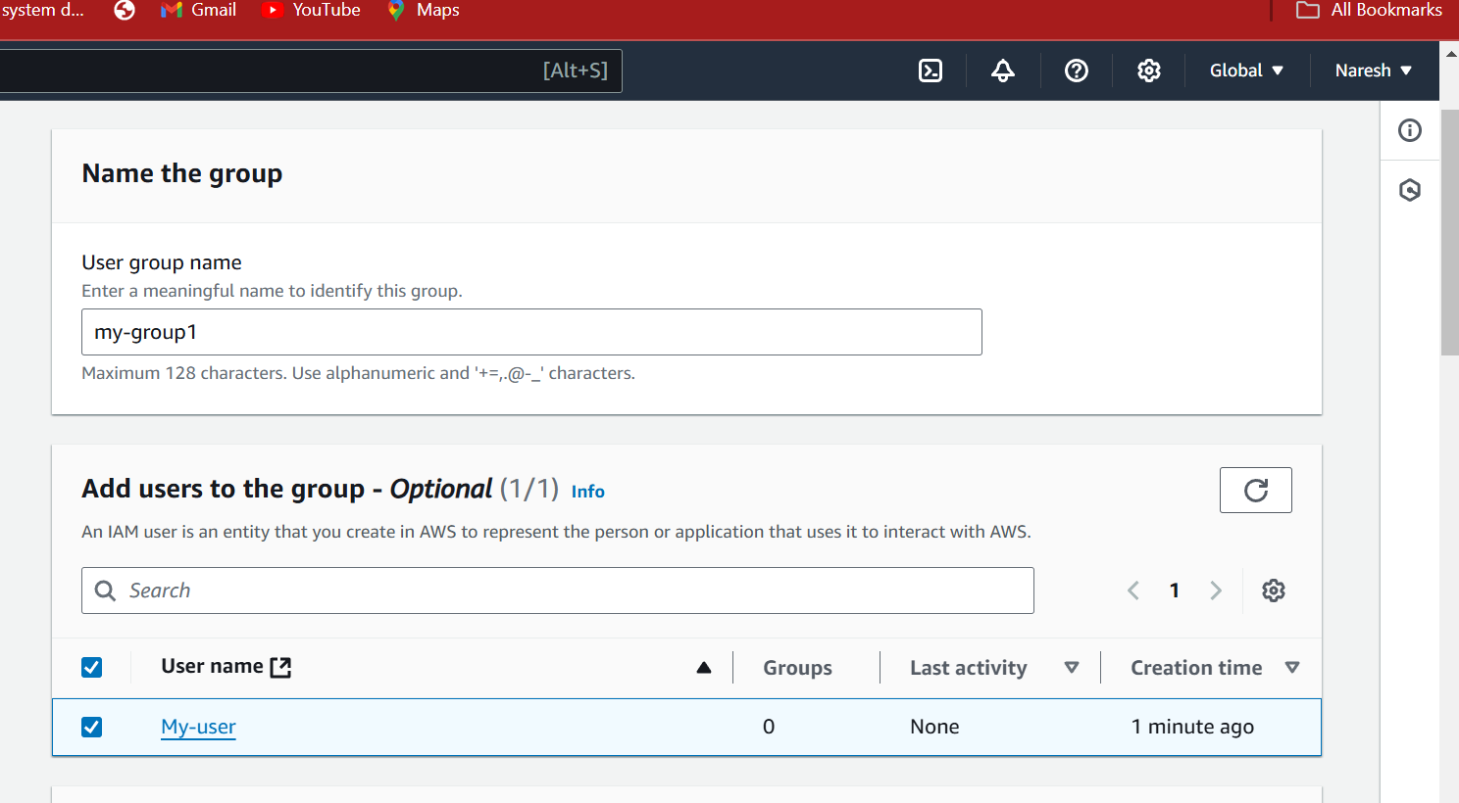

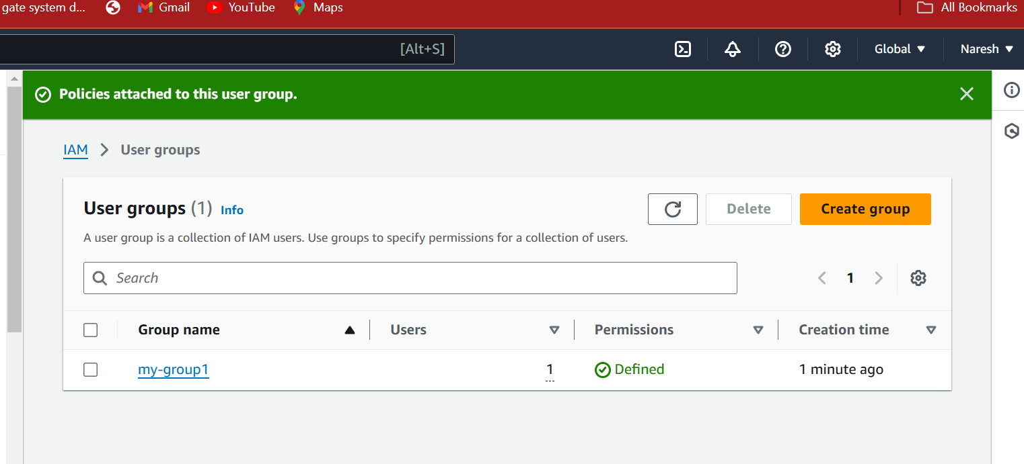

1. Create a new user with name Devops and add to the group created in task2.

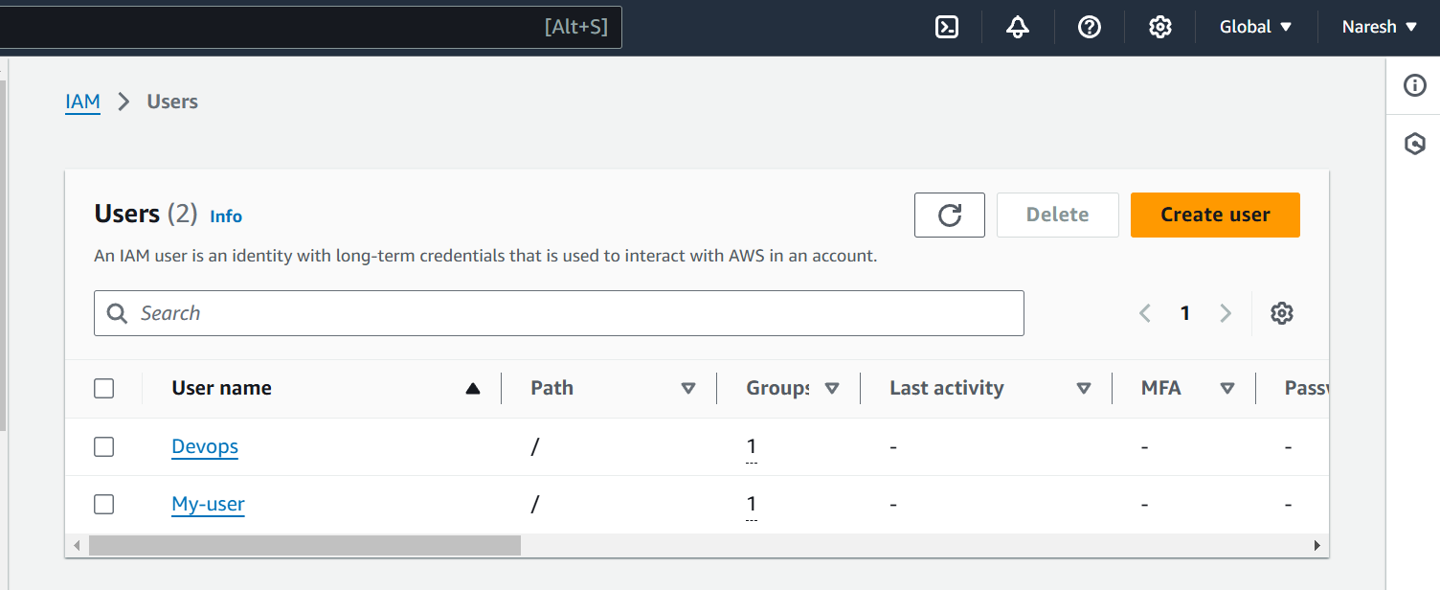

1. Write a bash script to create a IAM user with VPC full access.

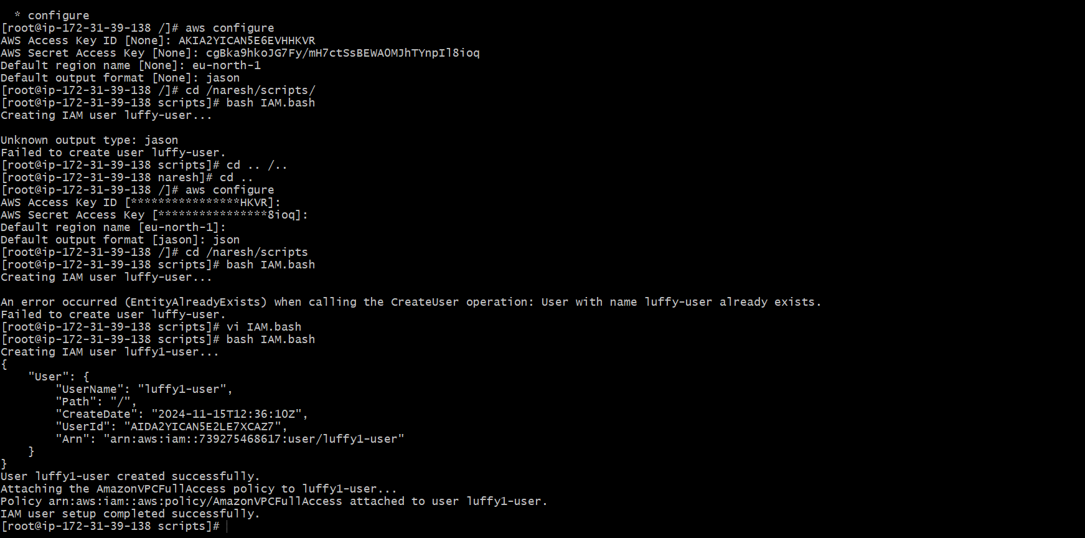

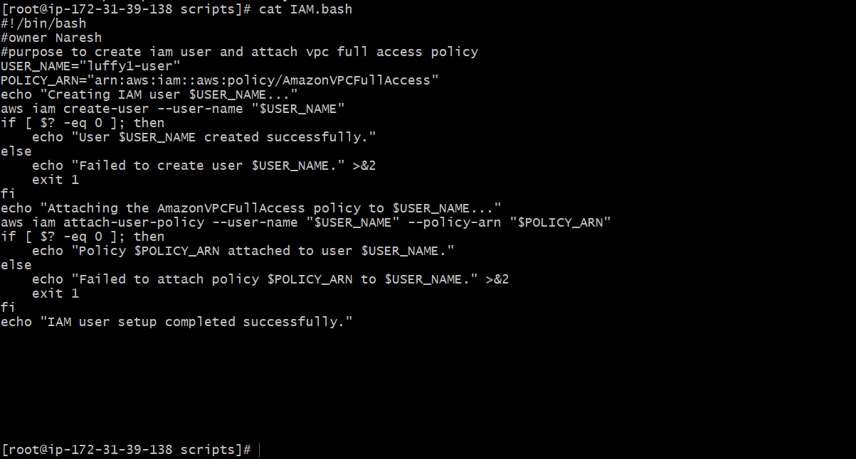

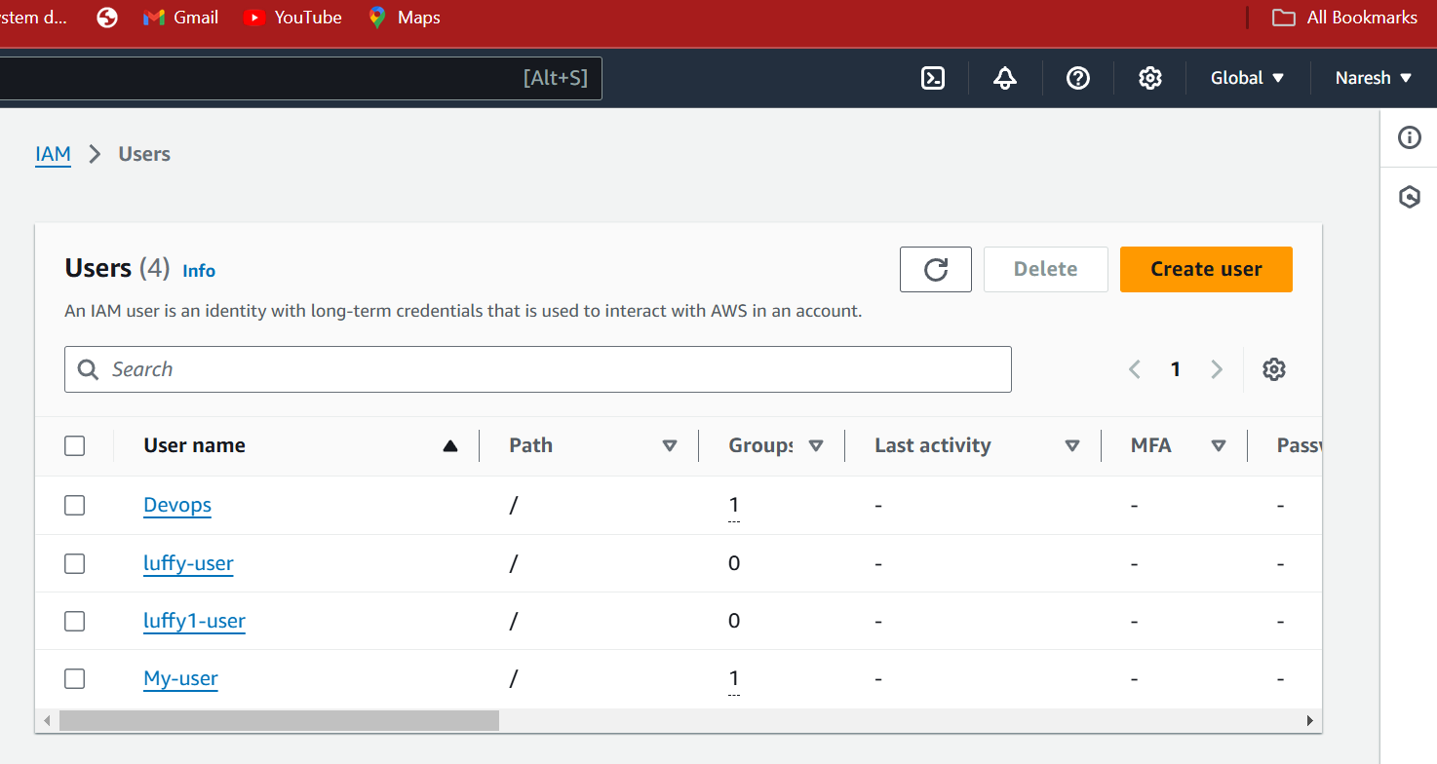

1. Create a IAM policy to access ec2 for a specific user in specific regions only.

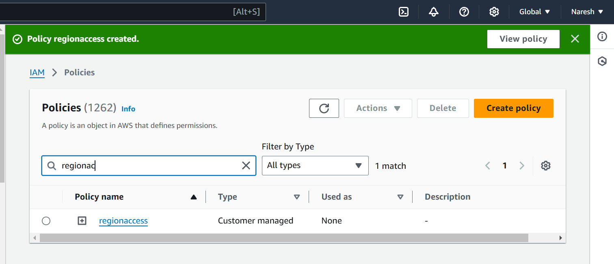

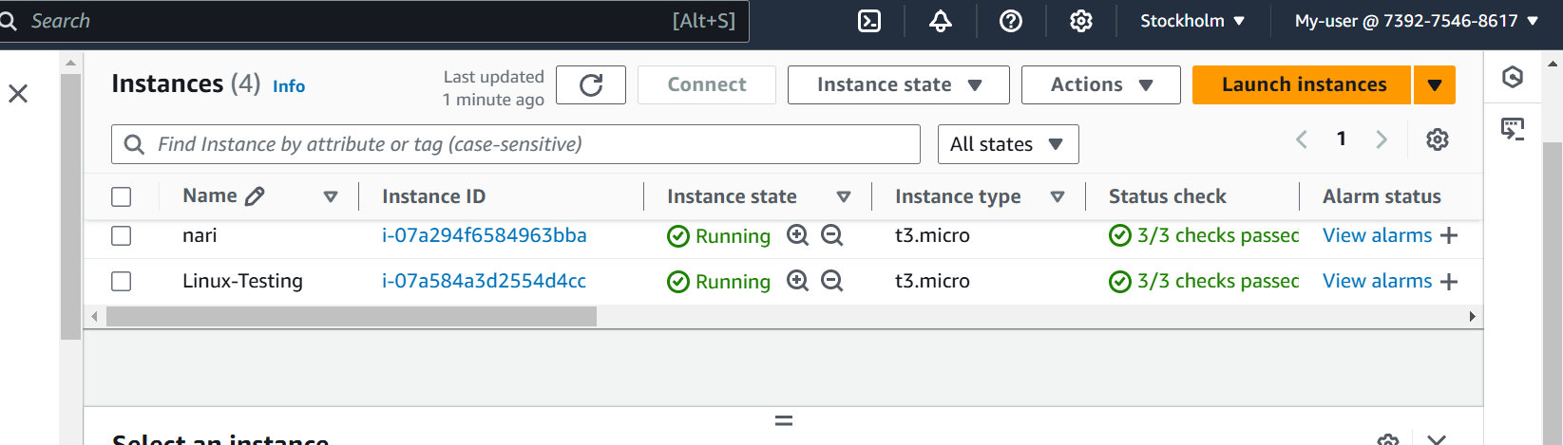

1. We have two accounts Account A and Account B, Account A user should access s3 bucket in Account B.